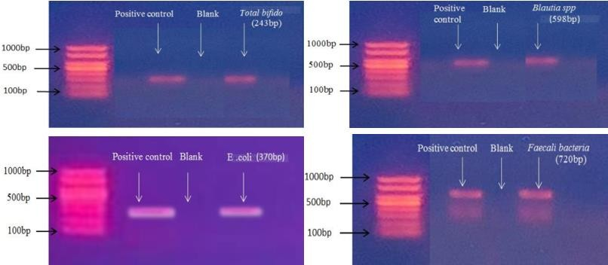
Supplementary file 1

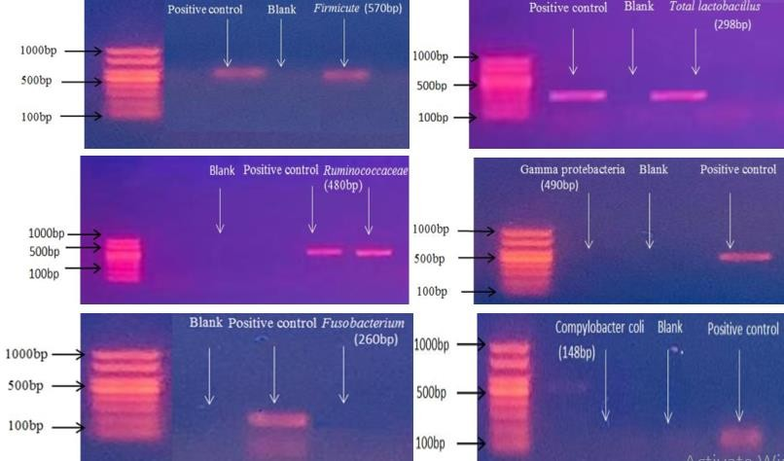

Fig 2. Representative bands for Total Bifido, Blautia spp ,E. coli ,Faecali ,Firmicutes ,Total Lactobacillus, Ruminococcaceae ,Gamma Protebacteria ,Fusobacterium and Compylobactor coli bacteria in fecal sample of human population in rural and urban areas by PCR.

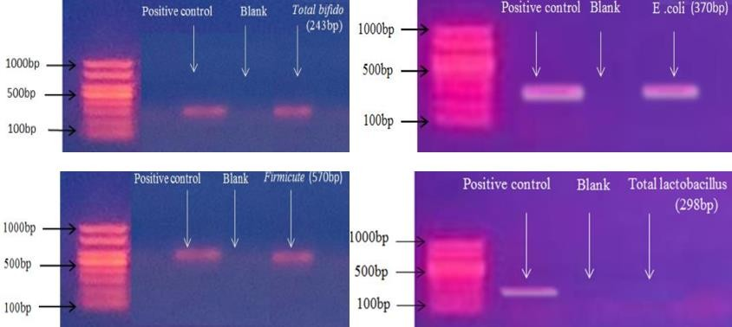
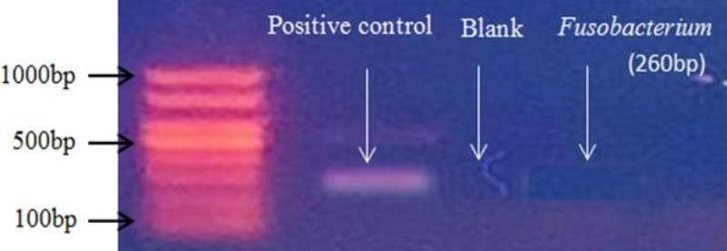

Fig.4.Representative bands for Total Bifido,E. coli ,Firmicutes ,Total Lactobacillus Fusobacterium in oral sample of human population by PCR.

